

**E COMMERCE MANAGEMENT SYSTEM**

**A MINI PROJECT REPORT**

**Submitted by**

**ASHIKHASHREE KARTHIKEYAN 231501021**

**AKSHAYA B 231501010**

**ASHWIN T 231501024**

**AKAASH SAI 231501009**

**In partial fulfilment for the award of the degree of**

**BACHELOR OF ENGINEERING**

**IN**

**COMPUTER SCIENCE AND ENGINEERING**

**RAJALAKSHMI ENGINEERING COLLEGE (AUTONOMOUS)**

**THANDALAM**

**CHENNAI-602105**



**BONAFIDE CERTIFICATE**

Certified that this project report “**E COMMERCE MANAGEMENT** **SYSTEM ”** is the bonafide work of **“ASHIKHASHREE KARTHIKEYAN(231501021), AKSHAYA B (231501010), ASHWIN T (231501024), AKAASH SAI(231501009)”** who carried out the project work under my supervision.

**Submitted for the Practical Examination held on _________________**

**SIGNATURE**

**Mr. U. Kumaran,**

**Assistant Professor AIML,**

**Rajalakshmi Engineering College,**

**(Autonomous),**

**Thandalam, Chennai - 602 105**

**INTERNAL EXAMINER EXTERNAL EXAMINER**

**ABSTRACT**

The e-commerce website provides a comprehensive platform for online shopping, offering a wide selection of products across diverse categories such as electronics, fashion, and home goods. With an intuitive and user-friendly interface, the site enables customers to easily browse, search, and filter items based on various criteria such as price, brand, and ratings. The platform also supports personalized accounts, allowing users to manage preferences, track order history, and store payment details for faster transactions.

To enhance the shopping experience, the website integrates secure payment gateways, ensuring safe and smooth transactions via multiple methods, including credit cards, digital wallets, and bank transfers. Customer engagement is further boosted through features like reviews and ratings, which help shoppers make informed decisions, as well as personalized product recommendations based on user behavior. The platform also promotes customer loyalty with exclusive discounts, seasonal offers, and reward programs designed to encourage repeat business.

Designed with responsiveness in mind, the website offers a seamless mobile experience, ensuring users can access the platform across devices—from desktops to smartphones—without any loss of functionality. This mobile-first design reflects the growing demand for flexibility in shopping on the go. By combining ease of use, security, and personalized features, the website strives to deliver a smooth, satisfying shopping experience, making it convenient and enjoyable for users to find, purchase, and enjoy their products.

In addition to its core features, the e-commerce platform emphasizes exceptional customer service, offering multiple support channels such as live chat, email, and phone assistance to address inquiries, resolve issues, and provide guidance throughout the shopping journey. The website also provides a hassle-free return and exchange policy, ensuring customers feel confident in their purchases. Real-time order tracking allows users to stay updated on the status of their deliveries, enhancing transparency and trust. By continuously evolving with the latest technological advancements and customer feedback, the platform aims to stay at the forefront of online shopping, meeting the ever-changing needs and expectations of modern consumers.

**TABLE OF CONTENT**

**1. INTRODUCTION**

* 1. **Introduction**

**1.2 Objective**

**2. SURVEY OF TECHNOLOGIES**

**2.1 Software description**

**2.2 Languages**

**2.2.1 HTML**

**2.2.2 CSS**

**2.2.3 PHP**

**2.2.4 MySQL**

**3. REQUIREMENTS AND ANALYSIS**

**3.1 Requirement Specification**

**3.2 Hardware and Software Requirements**

**3.3 Data flow diagram**

**3.3.1 Level 0**

**3.3.2 Level 1**

**3.3 Data Dictionary**

**3.4 ER-Diagram**

**3. 5 Normalization**

**4. PROGRAM CODE**

**4.1 Code Details and Code Efficiency**

**5. Result and Discussion**

**6. References**

**7. Conclusion**

**1. INTRODUCTION**

**1.1:INTRODUCTION:**

An e-commerce website is a software platform designed to streamline the buying and selling of goods online. It enables businesses to showcase products and provides customers with a convenient way to browse, add items to their cart, and make purchases. This system automates various retail functions, such as inventory tracking, order processing, and payment handling, making online transactions smooth and efficient.

The platform allows administrators to manage product listings, track stock levels, and handle customer orders, while customers benefit from a seamless shopping experience with options to search for products, make purchases, and view their order history. An e-commerce website serves as a digital storefront, enhancing the accessibility and reach of a business by enabling customers to shop anytime, anywhere.

**1.2 OBJECTIVE**

The primary objective of the e-commerce website is to provide a unified platform for managing the various facets of the online shopping process, including products, customers, orders, inventory, and payment transactions. By centralizing these functions, the platform ensures that all business operations are streamlined, making it easier for both administrators and users to navigate the system. The website is designed to facilitate seamless product management, enabling administrators to easily update product listings, manage detailed descriptions, pricing, and images, as well as monitor inventory levels in real-time to prevent stockouts or overstocking.

The platform is also built to improve operational efficiency by automating key processes such as order processing, payment verification, and customer account management. Administrators have access to a secure dashboard that allows them to oversee all aspects of the e-commerce process, from tracking orders and managing customer data to handling returns and exchanges. This system provides a comprehensive overview of daily operations, ensuring that orders are processed quickly, inventory is replenished when necessary, and customers receive timely support and updates.

Furthermore, the website integrates a secure payment gateway to handle transactions efficiently and safely. Administrators can track payments, manage refunds, and ensure that financial data is protected. The system also includes features for personalized customer service, such as managing user profiles and preferences, offering tailored promotions, and handling customer inquiries. Overall, the platform aims to enhance operational workflows, reduce manual effort, and provide an optimal shopping experience for customers, while giving administrators the tools they need to effectively manage the business.

**2. SURVEY OF TECHNOLOGY**

**2.1: Software Description**

NetBeans is a free, open-source Integrated Development Environment (IDE) primarily used for Java development. It provides a comprehensive set of tools for building, debugging, and deploying applications. Known for its modular structure, NetBeans allows developers to manage complex projects efficiently through its support for Java, as well as languages like PHP, HTML, and JavaScript. It also offers a range of plugins and extensions, enabling developers to customize the IDE to suit their specific needs and work on diverse project types, from desktop to web applications.

**2.2: Languages**

* **HTML (HyperText Markup Language)** is the standard language for creating and structuring content on the web, defining elements like headings, paragraphs, links, and images. HTML provides the backbone of all web pages, organizing the content and ensuring proper rendering across browsers and devices.
* **CSS (Cascading Style Sheets)** is used to style HTML elements, controlling the layout, design, colors, fonts, and overall appearance of a web page. CSS allows for separation of content and presentation, enabling a clean, efficient, and consistent design across multiple pages or platforms.
* **MySQL** is an open-source relational database management system that uses SQL to manage and store data in structured tables, making it ideal for dynamic, data-driven applications. It is known for its high performance, reliability, and ease of use, often serving as the database backend for web applications and content management systems.
* **Java** is a versatile, object-oriented programming language used for building platform-independent applications, known for its reliability, scalability, and strong support for web and enterprise-level development. Java’s extensive libraries and frameworks make it a popular choice for creating robust, secure applications across a variety of domains, including mobile, web, and enterprise systems.

**3. REQUIREMENT AND ANALYSIS**

**3.1 Requirement specification**

**User Requirements**  
The e-commerce system should allow users to browse products by categories, search for specific items by name, price range, and filter based on product attributes. Users should be able to register, log in, view product details, add products to the shopping cart, and complete the checkout process. Administrators should be able to manage product listings, orders, and customer accounts.

**System Requirements**  
The system should provide real-time inventory management, secure user authentication, and a smooth checkout process. There should be backup mechanisms for database and order data to ensure data integrity and security. The operating system should be Windows 10 or higher, and the website should be accessible through modern web browsers.

**3.2 HARDWARE AND SOFTWARE REQUIREMENTS**

**Software Requirements**

* **Operating System**: Windows 10 or higher
* **Front End**: HTML, CSS, JavaScript
* **Back End**: Java (with NetBeans IDE)
* **Database**: MySQL
* **Web Browser**: Chrome, Firefox, or any modern web browser
* **Additional Software**: Apache Tomcat (for deploying Java web applications)

**Hardware Requirements**

* **Desktop PC or Laptop**
* **Printer** (optional for generating invoices or receipts)
* **Operating System**: Windows 10 or higher
* **Processor**: Intel® Core™ i3 or equivalent
* **RAM**: 4 GB or higher
* **Storage**: Minimum 500 MB of free disk space
* **Monitor Resolution**: 1024 x 768 or higher

**3.3 Data flow diagram**

**Level 0 DFD**

:+------------------+ +--------------------+ +------------------+

| Customer |<----->| E-Commerce System |<----->| Admin |

+------------------+ +--------------------+ +------------------+

| | |

| | |

v v v

User Data Product Data Admin Data

**Level 1 - Detailed Diagram**

+---------------------+ +---------------------+ +------------------+

| Customer Registration| ---> | E-Commerce System | <--> | Admin Panel |

| & Login | | | | |

+---------------------+ +---------------------+ +------------------+

| | |

v v v

User Auth (Login) Product Search Product/Order Management

| | |

v v v

+-------------------+ +-------------------+ +-------------------+

| Shopping Cart |<---->| Checkout & Payment |<--->| Order Management |

| Management | | | | |

+-------------------+ +-------------------+ +-------------------+

**3.3 DATA DICTIONARY**

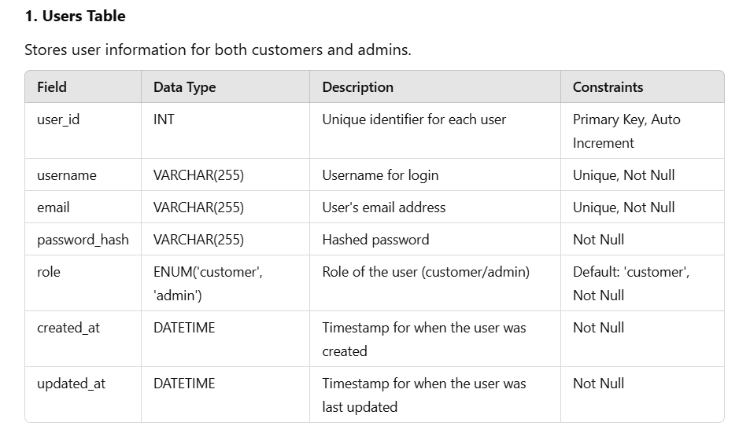

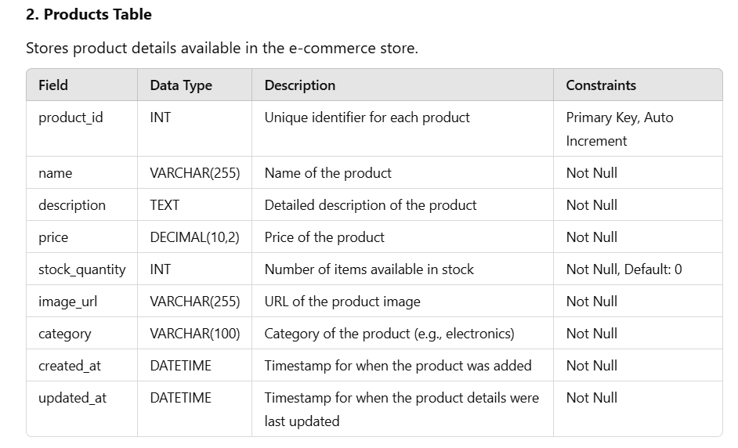

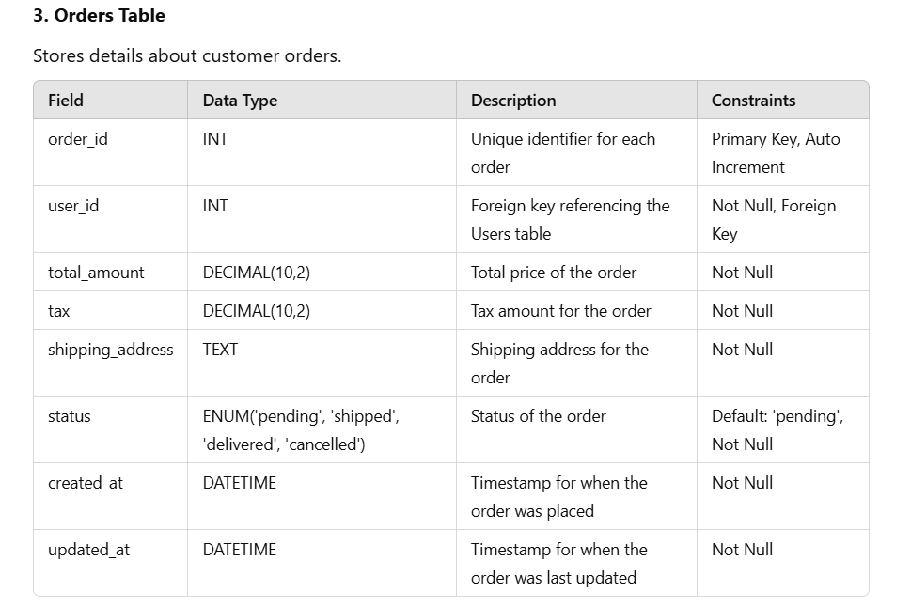

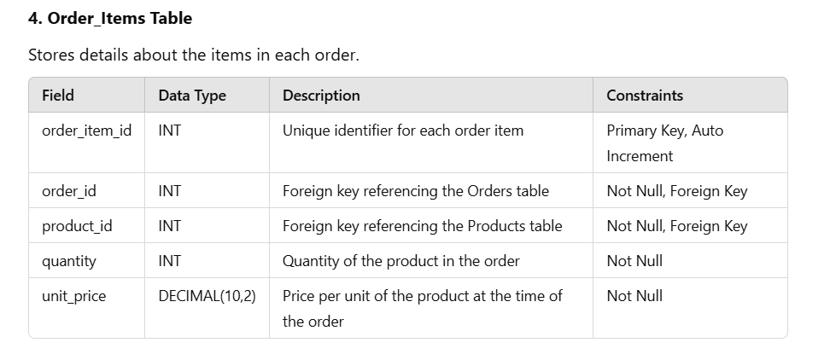

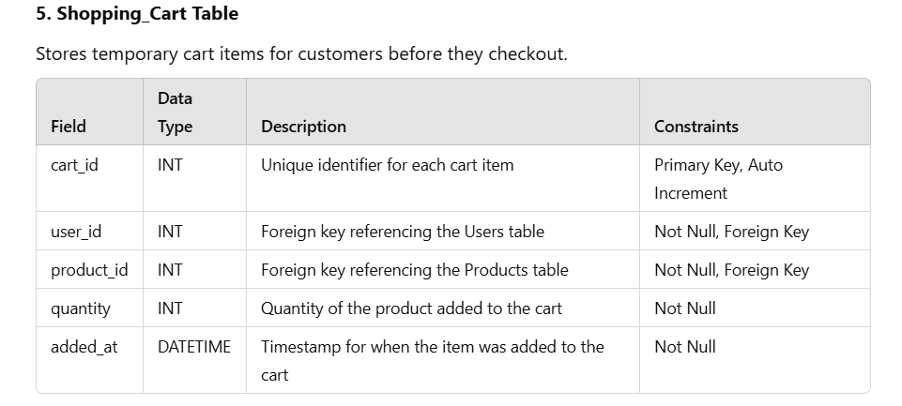

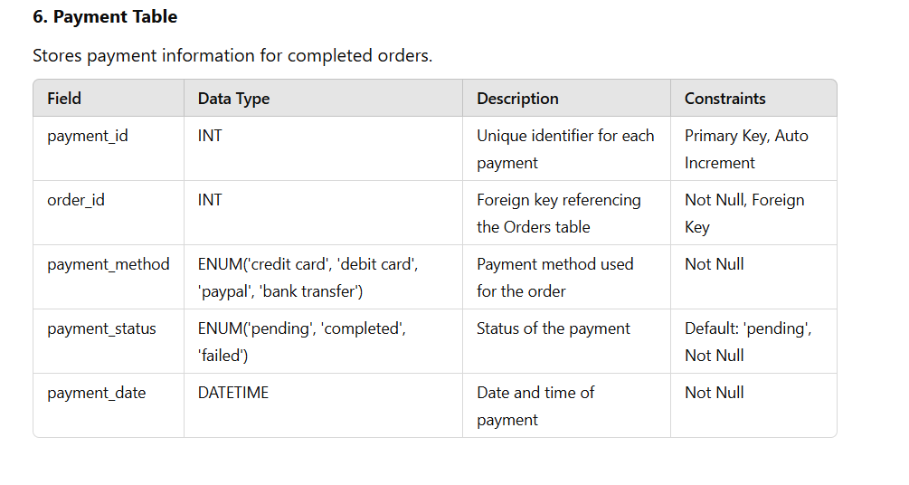

**3.4 ER DIAGRAM**

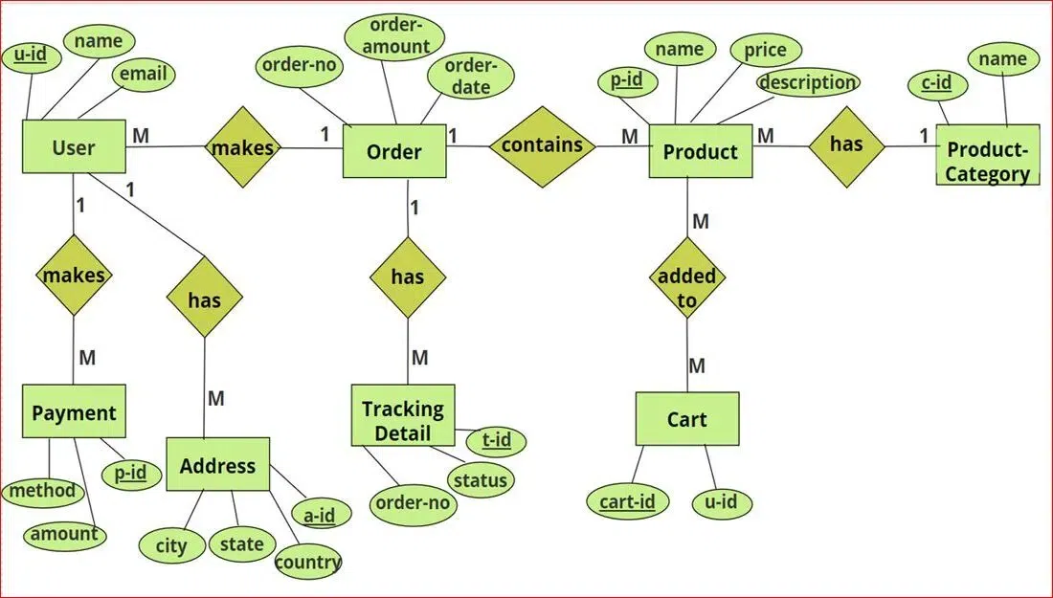

The ER diagram for an e-commerce platform includes these main entities:

1. **User**: Stores user information.
2. **Product**: Lists products with details.
3. **Order**: Records user purchases.
4. **OrderItem**: Details products within orders.
5. **CartItem**: Tracks items in users' carts.

**Relationships**:

* A User can place multiple Orders.
* An Order can include multiple OrderItems.
* Products are linked to OrderItems and CartItems.
* Users can have multiple CartItems.

**3. 5 NORMALIZATION**

Unnormalized Table:

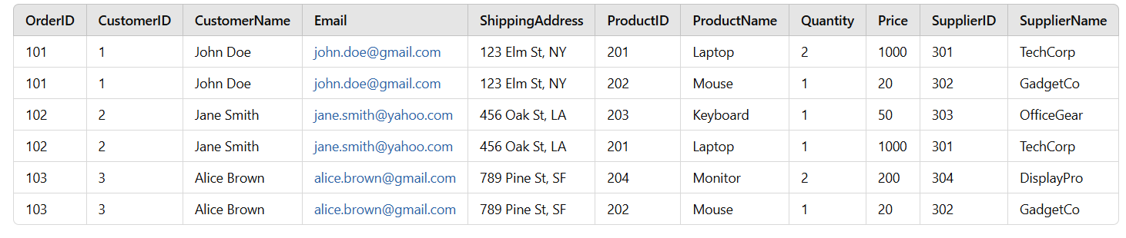

First Normal Form (1NF)

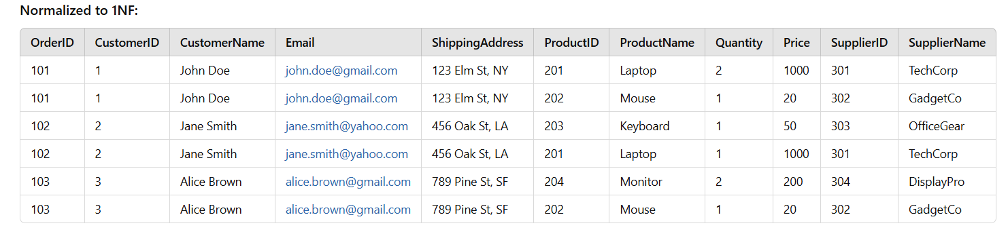

Normalized to 2NF:

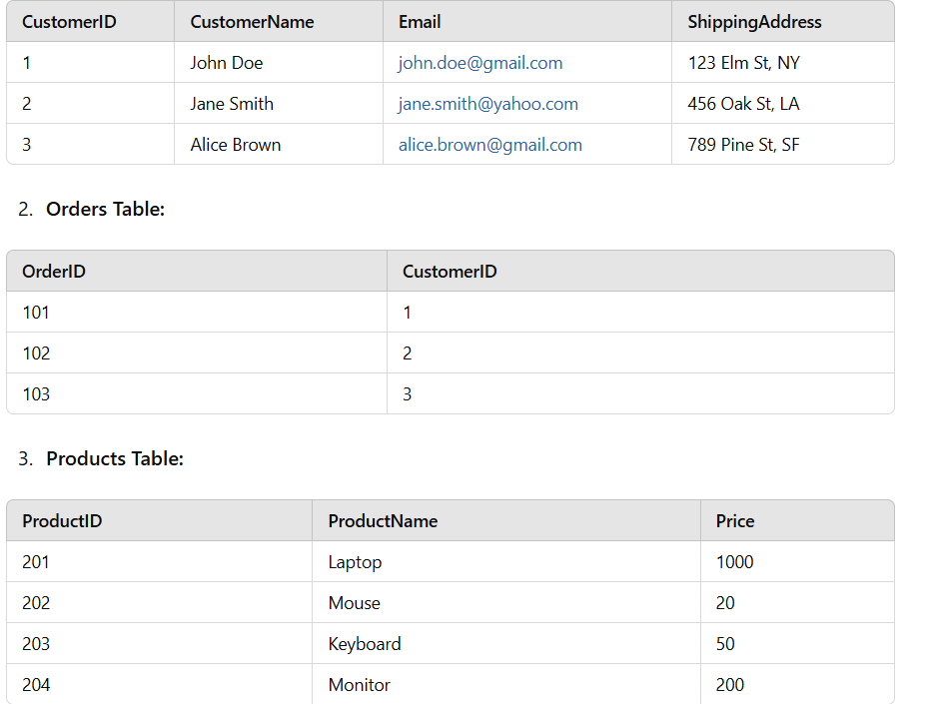

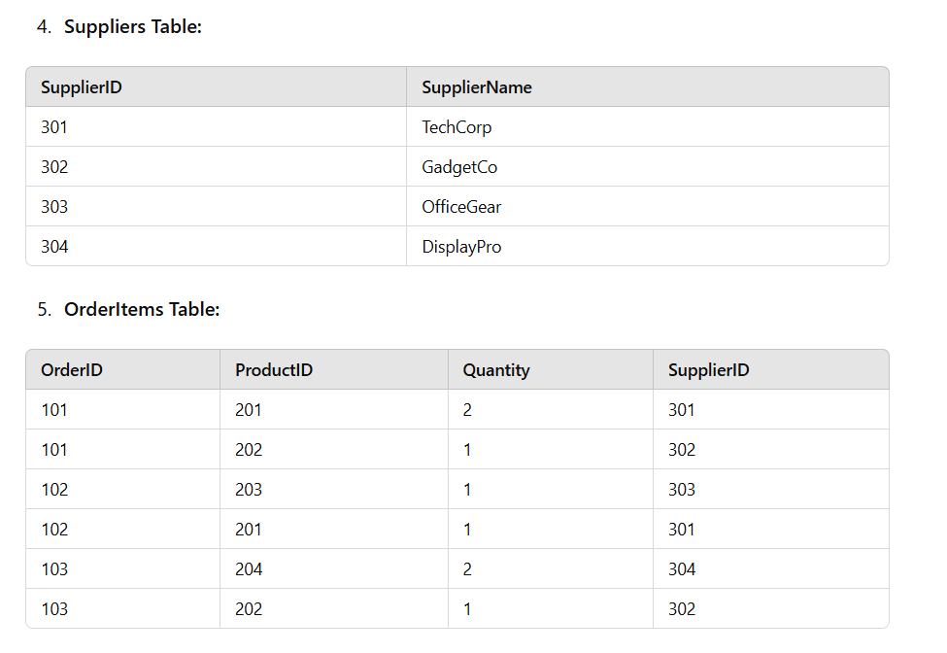

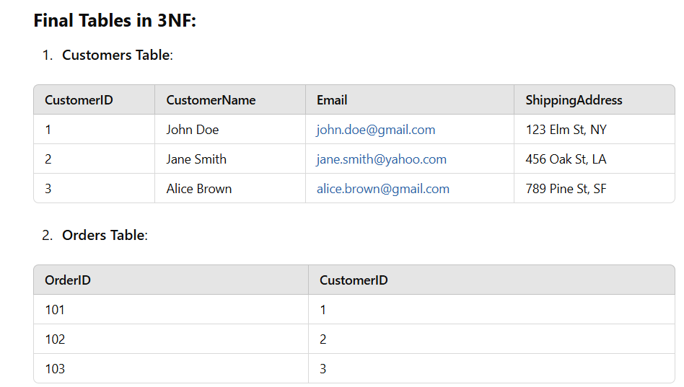

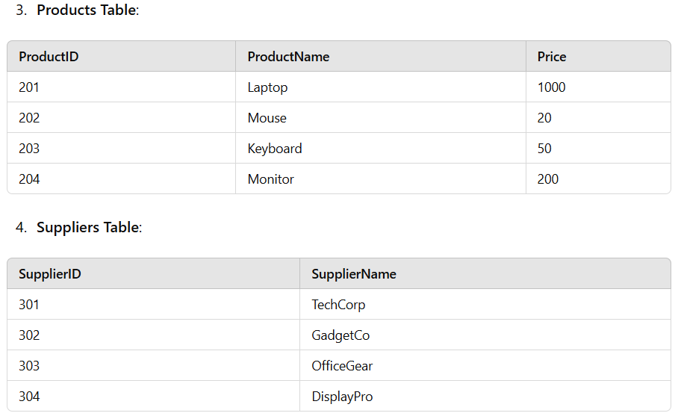

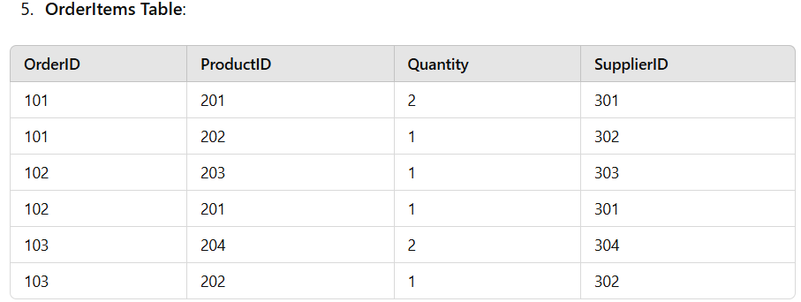

**4 PROGRAM CODE**

**4.1. CODE DETAILS AND CODE EFFICIENCY**

**FRONTEND :**

<html lang="en">

<head>

<meta charset="UTF-8">

<meta name="viewport" content="width=device-width, initial-scale=1.0">

<title>E-commerce Sign Up / Sign In</title>

<style>

/* Global Styles */

body {

font-family: 'Helvetica Neue', Arial, sans-serif;

background: linear-gradient(120deg, #f6d365 0%, #fda085 100%);

display: flex;

justify-content: center;

align-items: center;

height: 100vh;

margin: 0;

}

/* Container Styles */

.container {

background: rgba(255, 255, 255, 0.9);

padding: 50px;

border-radius: 12px;

box-shadow: 0 0 25px rgba(0, 0, 0, 0.2);

width: 100%;

max-width: 500px;

text-align: center;

}

.container h2 {

margin-bottom: 30px;

font-size: 24px;

color: #333;

}

/* Form Input Styles */

.container input[type="text"],

.container input[type="password"],

.container input[type="email"] {

width: 100%;

padding: 15px;

margin: 15px 0;

border: 1px solid #ccc;

border-radius: 6px;

font-size: 16px;

}

/* Button Styles */

.container button {

width: 100%;

padding: 15px;

background-color: #ff6600;

border: none;

border-radius: 6px;

color: #fff;

font-size: 18px;

cursor: pointer;

transition: background-color 0.3s ease;

}

.container button:hover {

background-color: #cc5200;

}

/* Link Styles */

.container a {

display: block;

margin: 15px 0;

color: #ff6600;

text-decoration: none;

}

.container a:hover {

text-decoration: underline;

}

/* Tabs Styles */

.tabs {

display: flex;

justify-content: center;

margin-bottom: 30px;

}

.tabs button {

flex: 1;

padding: 15px;

background-color: #eee;

border: none;

border-radius: 6px 6px 0 0;

cursor: pointer;

transition: background-color 0.3s ease;

}

.tabs button.active {

background-color: #ff6600;

color: #fff;

}

/* Form Wrapper Styles */

.form-wrapper {

display: none;

}

.form-wrapper.active {

display: block;

}

</style>

<script>

function showForm(formId) {

document.querySelectorAll('.form-wrapper').forEach(form => {

form.classList.remove('active');

});

document.getElementById(formId).classList.add('active');

document.querySelectorAll('.tabs button').forEach(tab => {

tab.classList.remove('active');

});

document.getElementById(formId + '-tab').classList.add('active');

}

window.onload = function() {

showForm('signin-form'); // Show sign in form by default

};

</script>

</head>

<body>

<div class="container">

<div class="tabs">

<button id="signin-form-tab" class="active" onclick="showForm('signin-form')">Sign In</button>

<button id="signup-form-tab" onclick="showForm('signup-form')">Sign Up</button>

</div>

<div id="signin-form" class="form-wrapper active">

<h2>Sign In</h2>

<form>

<input type="text" placeholder="Username" required>

<input type="password" placeholder="Password" required>

<button type="submit">Sign In</button>

<a href="#">Forgot Password?</a>

</form>

</div>

<div id="signup-form" class="form-wrapper">

<h2>Sign Up</h2>

<form>

<input type="text" placeholder="Username" required>

<input type="email" placeholder="Email" required>

<input type="password" placeholder="Password" required>

<button type="submit">Sign Up</button>

</form>

</div>

</div>

</body>

</html>

HOME PAGE

<!DOCTYPE html>

<html lang="en">

<head>

<meta charset="UTF-8">

<meta name="viewport" content="width=device-width, initial-scale=1.0">

<title>E-commerce Home Page</title>

<style>

/* Global Styles */

body {

font-family: 'Helvetica Neue', Arial, sans-serif;

background-color: #f4f4f4;

margin: 0;

padding: 0;

}

header {

background-color: #ff6600;

color: #fff;

padding: 10px 0;

text-align: center;

}

header h1 {

margin: 0;

}

/* Navbar Styles */

.navbar {

display: flex;

justify-content: center;

background-color: #333;

overflow: hidden;

}

.navbar a {

float: left;

display: block;

color: white;

text-align: center;

padding: 14px 20px;

text-decoration: none;

}

.navbar a:hover {

background-color: #ddd;

color: black;

}

/* Main Content Styles */

.main-content {

padding: 20px;

}

.section-title {

font-size: 24px;

color: #333;

margin-bottom: 20px;

}

.product-grid {

display: grid;

grid-template-columns: repeat(auto-fill, minmax(200px, 1fr));

gap: 20px;

}

.product {

background-color: #fff;

border-radius: 8px;

box-shadow: 0 0 10px rgba(0, 0, 0, 0.1);

padding: 15px;

text-align: center;

}

.product img {

width: 100%;

height: auto;

border-bottom: 1px solid #eee;

margin-bottom: 10px;

}

.product h3 {

font-size: 18px;

color: #333;

}

.product p {

font-size: 14px;

color: #777;

}

.product .details {

margin-top: 10px;

font-size: 12px;

color: #999;

}

/* Footer Styles */

footer {

background-color: #333;

color: #fff;

text-align: center;

padding: 10px 0;

position: fixed;

bottom: 0;

width: 100%;

}

</style>

</head>

<body>

<header>

<h1>My E-commerce Site</h1>

</header>

<div class="navbar">

<a href="#">Home</a>

<a href="#">Products</a>

<a href="#">Categories</a>

<a href="#">Contact</a>

</div>

<div class="main-content">

<div class="section-title">Featured Products</div>

<div class="product-grid">

<div class="product">

<img src="product1.jpg" alt="Product 1">

<h3>Product 1</h3>

<p>High-quality product for everyday use.</p>

<div class="details">Product ID: 101</div>

</div>

<div class="product">

<img src="product2.jpg" alt="Product 2">

<h3>Product 2</h3>

<p>Durable and reliable, perfect for your needs.</p>

<div class="details">Product ID: 102</div>

</div>

<div class="product">

<img src="product3.jpg" alt="Product 3">

<h3>Product 3</h3>

<p>Innovative design and excellent performance.</p>

<div class="details">Product ID: 103</div>

</div>

</div>

</div>

<footer>

&copy; 2024 My E-commerce Site. All rights reserved.

</footer>

</body>

</html>

Product Detail Page:

<!DOCTYPE html>

<html lang="en">

<head>

<meta charset="UTF-8">

<meta name="viewport" content="width=device-width, initial-scale=1.0">

<title>Product Listing Page</title>

<style>

/* Global Styles */

body {

font-family: 'Helvetica Neue', Arial, sans-serif;

background-color: #f4f4f4;

margin: 0;

padding: 0;

}

header {

background-color: #ff6600;

color: #fff;

padding: 10px 0;

text-align: center;

}

header h1 {

margin: 0;

}

/* Navbar Styles */

.navbar {

display: flex;

justify-content: center;

background-color: #333;

overflow: hidden;

}

.navbar a {

float: left;

display: block;

color: white;

text-align: center;

padding: 14px 20px;

text-decoration: none;

}

.navbar a:hover {

background-color: #ddd;

color: black;

}

/* Main Content Styles */

.main-content {

padding: 20px;

}

.section-title {

font-size: 24px;

color: #333;

margin-bottom: 20px;

}

.product-grid {

display: grid;

grid-template-columns: repeat(auto-fill, minmax(200px, 1fr));

gap: 20px;

}

.product {

background-color: #fff;

border-radius: 8px;

box-shadow: 0 0 10px rgba(0, 0, 0, 0.1);

padding: 15px;

text-align: center;

}

.product img {

width: 100%;

height: auto;

border-bottom: 1px solid #eee;

margin-bottom: 10px;

}

.product h3 {

font-size: 18px;

color: #333;

}

.product p {

font-size: 14px;

color: #777;

}

.product .details {

margin-top: 10px;

font-size: 12px;

color: #999;

}

/* Footer Styles */

footer {

background-color: #333;

color: #fff;

text-align: center;

padding: 10px 0;

position: fixed;

bottom: 0;

width: 100%;

}

</style>

</head>

<body>

<header>

<h1>My E-commerce Site</h1>

</header>

<div class="navbar">

<a href="#">Home</a>

<a href="#">Products</a>

<a href="#">Categories</a>

<a href="#">Contact</a>

</div>

<div class="main-content">

<div class="section-title">Product Listing</div>

<div class="product-grid">

<div class="product">

<img src="product1.jpg" alt="Product 1">

<h3>Product 1</h3>

<p>High-quality product for everyday use.</p>

<div class="details">Product ID: 101</div>

<div class="details">Price: $29.99</div>

<div class="details">Available: In Stock</div>

</div>

<div class="product">

<img src="product2.jpg" alt="Product 2">

<h3>Product 2</h3>

<p>Durable and reliable, perfect for your needs.</p>

<div class="details">Product ID: 102</div>

<div class="details">Price: $49.99</div>

<div class="details">Available: In Stock</div>

</div>

<div class="product">

<img src="product3.jpg" alt="Product 3">

<h3>Product 3</h3>

<p>Innovative design and excellent performance.</p>

<div class="details">Product ID: 103</div>

<div class="details">Price: $39.99</div>

<div class="details">Available: Out of Stock</div>

</div>

<div class="product">

<img src="product4.jpg" alt="Product 4">

<h3>Product 4</h3>

<p>Stylish and comfortable, perfect for daily wear.</p>

<div class="details">Product ID: 104</div>

<div class="details">Price: $59.99</div>

<div class="details">Available: In Stock</div>

</div>

<div class="product">

<img src="product5.jpg" alt="Product 5">

<h3>Product 5</h3>

<p>Compact and efficient, ideal for small spaces.</p>

<div class="details">Product ID: 105</div>

<div class="details">Price: $19.99</div>

<div class="details">Available: In Stock</div>

</div>

<div class="product">

<img src="product6.jpg" alt="Product 6">

<h3>Product 6</h3>

<p>Powerful and versatile, perfect for any task.</p>

<div class="details">Product ID: 106</div>

<div class="details">Price: $89.99</div>

<div class="details">Available: In Stock</div>

</div>

<div class="product">

<img src="product7.jpg" alt="Product 7">

<h3>Product 7</h3>

<p>Elegant design with top-notch functionality.</p>

<div class="details">Product ID: 107</div>

<div class="details">Price: $99.99</div>

<div class="details">Available: In Stock</div>

</div>

<div class="product">

<img src="product8.jpg" alt="Product 8">

<h3>Product 8</h3>

<p>Innovative technology for the modern home.</p>

<div class="details">Product ID: 108</div>

<div class="details">Price: $79.99</div>

<div class="details">Available: Out of Stock</div>

</div>

<div class="product">

<img src="product9.jpg" alt="Product 9">

<h3>Product 9</h3>

<p>Perfect blend of style and performance.</p>

<div class="details">Product ID: 109</div>

<div class="details">Price: $39.99</div>

<div class="details">Available: In Stock</div>

</div>

<div class="product">

<img src="product10.jpg" alt="Product 10">

<h3>Product 10</h3>

<p>High durability and excellent craftsmanship.</p>

<div class="details">Product ID: 110</div>

<div class="details">Price: $59.99</div>

<div class="details">Available: In Stock</div>

</div>

<div class="product">

<img src="product11.jpg" alt="Product 11">

<h3>Product 11</h3>

<p>Superior quality and unmatched performance.</p>

<div class="details">Product ID: 111</div>

<div class="details">Price: $69.99</div>

<div class="details">Available: Out of Stock</div>

</div>

<div class="product">

<img src="product12.jpg" alt="Product 12">

<h3>Product 12</h3>

<p>Designed for comfort and efficiency.</p>

<div class="details">Product ID: 112</div>

<div class="details">Price: $49.99</div>

<div class="details">Available: In Stock</div>

</div>

<div class="product">

<img src="product13.jpg" alt="Product 13">

<h3>Product 13</

Shopping Cart Page:

<!DOCTYPE html>

<html lang="en">

<head>

<meta charset="UTF-8">

<meta name="viewport" content="width=device-width, initial-scale=1.0">

<title>Shopping Cart</title>

<style>

/* Global Styles */

body {

font-family: 'Helvetica Neue', Arial, sans-serif;

background-color: #f4f4f4;

margin: 0;

padding: 0;

}

header {

background-color: #ff6600;

color: #fff;

padding: 10px 0;

text-align: center;

}

header h1 {

margin: 0;

}

/* Navbar Styles */

.navbar {

display: flex;

justify-content: center;

background-color: #333;

overflow: hidden;

}

.navbar a {

float: left;

display: block;

color: white;

text-align: center;

padding: 14px 20px;

text-decoration: none;

}

.navbar a:hover {

background-color: #ddd;

color: black;

}

/* Main Content Styles */

.main-content {

padding: 20px;

}

.section-title {

font-size: 24px;

color: #333;

margin-bottom: 20px;

}

.cart-table {

width: 100%;

border-collapse: collapse;

margin-bottom: 20px;

}

.cart-table th, .cart-table td {

padding: 15px;

text-align: left;

border-bottom: 1px solid #ddd;

}

.cart-table th {

background-color: #ff6600;

color: #fff;

}

.cart-table td {

background-color: #fff;

}

.cart-table img {

width: 50px;

height: auto;

}

.cart-summary {

text-align: right;

font-size: 18px;

color: #333;

}

.cart-summary .total {

font-weight: bold;

margin-top: 10px;

}

.checkout-button {

background-color: #ff6600;

color: #fff;

padding: 10px 20px;

border: none;

border-radius: 4px;

cursor: pointer;

font-size: 18px;

}

.checkout-button:hover {

background-color: #cc5200;

}

/* Footer Styles */

footer {

background-color: #333;

color: #fff;

text-align: center;

padding: 10px 0;

position: fixed;

bottom: 0;

width: 100%;

}

</style>

</head>

<body>

<header>

<h1>My E-commerce Site</h1>

</header>

<div class="navbar">

<a href="#">Home</a>

<a href="#">Products</a>

<a href="#">Categories</a>

<a href="#">Contact</a>

</div>

<div class="main-content">

<div class="section-title">Shopping Cart</div>

<table class="cart-table">

<tr>

<th>Product</th>

<th>ID</th>

<th>Quantity</th>

<th>Price</th>

<th>Total</th>

</tr>

<tr>

<td><img src="product1.jpg" alt="Product 1"><br>Product 1</td>

<td>101</td>

<td>1</td>

<td>$29.99</td>

<td>$29.99</td>

</tr>

<tr>

<td><img src="product2.jpg" alt="Product 2"><br>Product 2</td>

<td>102</td>

<td>2</td>

<td>$49.99</td>

<td>$99.98</td>

</tr>

<tr>

<td><img src="product3.jpg" alt="Product 3"><br>Product 3</td>

<td>103</td>

<td>1</td>

<td>$39.99</td>

<td>$39.99</td>

</tr>

</table>

<div class="cart-summary">

<div>Subtotal: $169.96</div>

<div class="total">Total: $169.96</div>

<button class="checkout-button">Proceed to Checkout</button>

</div>

</div>

<footer>

&copy; 2024 My E-commerce Site. All rights reserved.

</footer>

</body>

</html>

backend

**Database Connection (db.php)**:

<?php

$servername = "localhost";

$username = "root";

$password = "";

$dbname = "ecommerce";

$conn = new mysqli($servername, $username, $password, $dbname);

if ($conn->connect_error) {

die("Connection failed: " . $conn->connect_error);

}

?>

Product Listing (products.php):

<?php

include 'db.php';

$sql = "SELECT id, name, description, price, image FROM products";

$result = $conn->query($sql);

if ($result->num_rows > 0) {

while($row = $result->fetch_assoc()) {

echo "<div class='product'>

<img src='" . $row["image"] . "' alt='" . $row["name"] . "'>

<h3>" . $row["name"] . "</h3>

<p>" . $row["description"] . "</p>

<p>Price: $" . $row["price"] . "</p>

<form method='post' action='cart.php'>

<input type='hidden' name='product_id' value='" . $row["id"] . "'>

<input type='submit' value='Add to Cart'>

</form>

</div>";

}

} else {

echo "0 results";

}

$conn->close();

?>

**Shopping Cart (cart.php)**:

<?php

session_start();

include 'db.php';

if ($_SERVER["REQUEST_METHOD"] == "POST") {

$product_id = $_POST["product_id"];

$sql = "SELECT id, name, price FROM products WHERE id='$product_id'";

$result = $conn->query($sql);

$product = $result->fetch_assoc();

if ($product) {

$item = array("id" => $product["id"], "name" => $product["name"], "price" => $product["price"], "quantity" => 1);

if (!isset($_SESSION["cart"])) {

$_SESSION["cart"] = array();

}

array_push($_SESSION["cart"], $item);

}

}

$cart = isset($_SESSION["cart"]) ? $_SESSION["cart"] : array();

$total = 0;

echo "<h2>Shopping Cart</h2>";

echo "<table><tr><th>Name</th><th>Price</th><th>Quantity</th><th>Total</th></tr>";

foreach ($cart as $item) {

$item_total = $item["price"] * $item["quantity"];

echo "<tr>

<td>" . $item["name"] . "</td>

<td>" . $item["price"] . "</td>

<td>" . $item["quantity"] . "</td>

<td>" . $item_total . "</td>

</tr>";

$total += $item_total;

}

echo "<tr><td colspan='3'>Grand Total</td><td>" . $total . "</td></tr></table>";

echo "<a href='checkout.php'>Proceed to Checkout</a>";

$conn->close();

?>

**Checkout Page (checkout.php)**:

<?php

session_start();

if ($_SERVER["REQUEST_METHOD"] == "POST") {

$billing_name = $_POST["billing_name"];

$billing_email = $_POST["billing_email"];

$billing_address = $_POST["billing_address"];

$billing_city = $_POST["billing_city"];

$billing_state = $_POST["billing_state"];

$billing_zip = $_POST["billing_zip"];

$billing_country = $_POST["billing_country"];

// Payment processing logic here

// Order confirmation and saving to database logic here

unset($_SESSION["cart"]);

echo "Order placed successfully!";

} else {

$cart = isset($_SESSION["cart"]) ? $_SESSION["cart"] : array();

$total = 0;

foreach ($cart as $item) {

$total += $item["price"] * $item["quantity"];

}

echo "<h2>Checkout</h2>";

echo "<form method='post' action='checkout.php'>

<h3>Billing Information</h3>

<label for='billing_name'>Name</label><input type='text' name='billing_name' required><br>

<label for='billing_email'>Email</label><input type='email' name='billing_email' required><br>

<label for='billing_address'>Address</label><input type='text' name='billing_address' required><br>

<label for='billing_city'>City</label><input type='text' name='billing_city' required><br>

<label for='billing_state'>State</label><input type='text' name='billing_state' required><br>

<label for='billing_zip'>Zip Code</label><input type='text' name='billing_zip' required><br>

<label for='billing_country'>Country</label><input type='text' name='billing_country' required><br>

<h3>Order Summary</h3>

<p>Total: $" . $total . "</p>

<button type='submit'>Confirm and Pay</button>

</form>";

}

?>

**5.USER DOCUMENTATION LOGIN PAGE**

**LOGIN PAGE:**

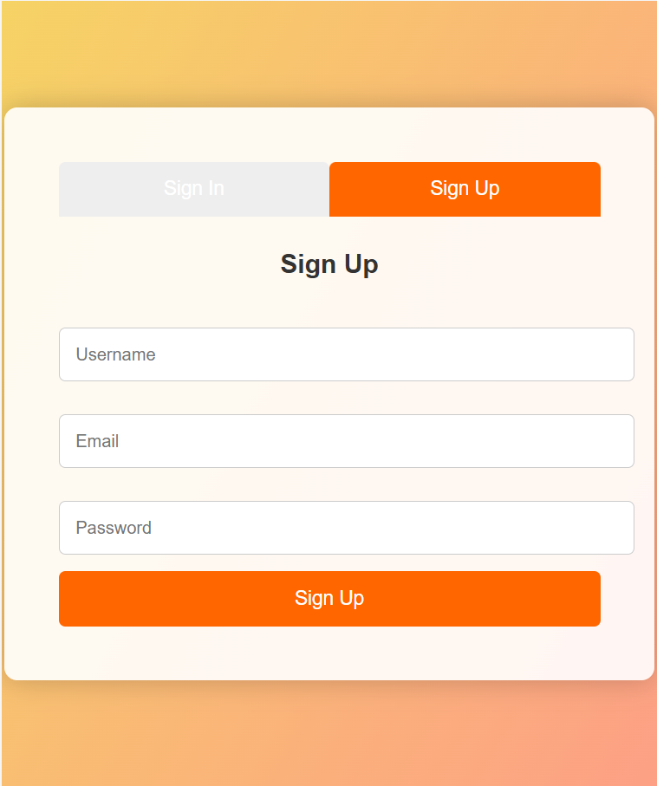

**SHOPPING CART PAGE:**

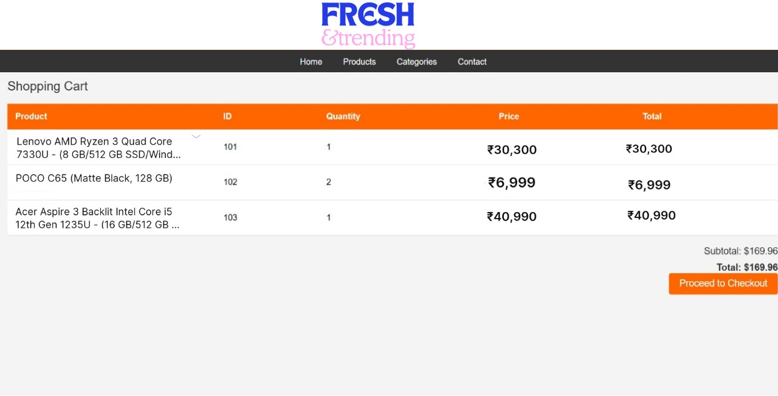

**CHECKOUT PAGE**

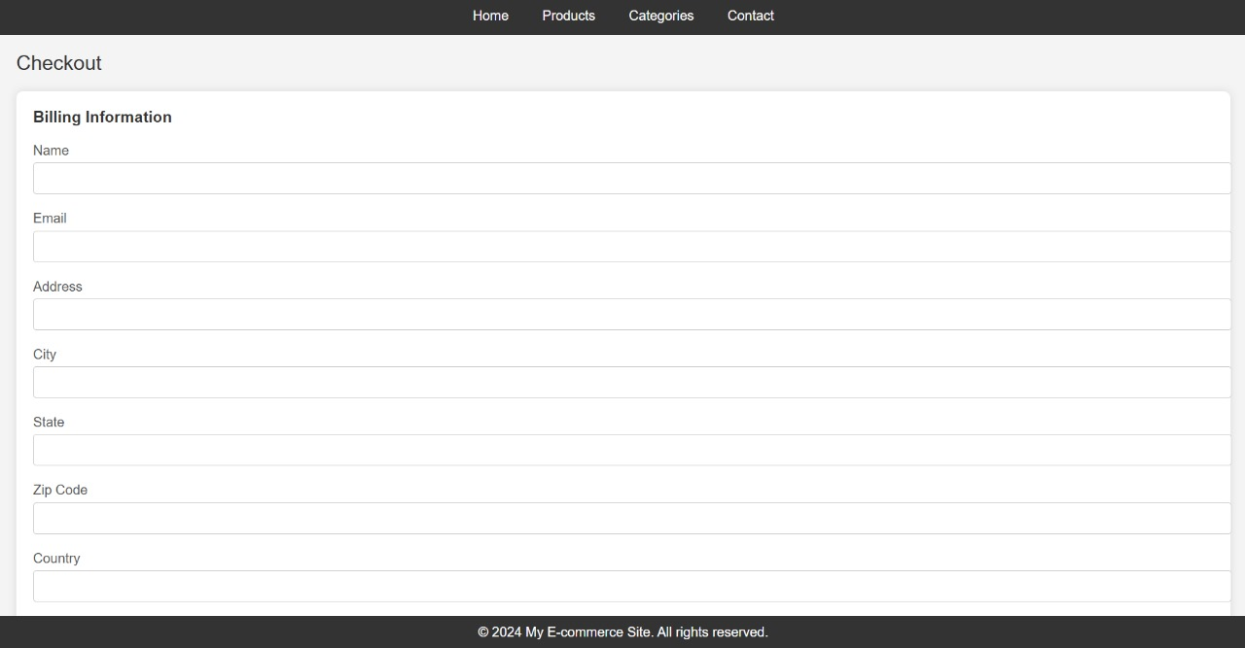

**CHECKOUT PAGE 2:**

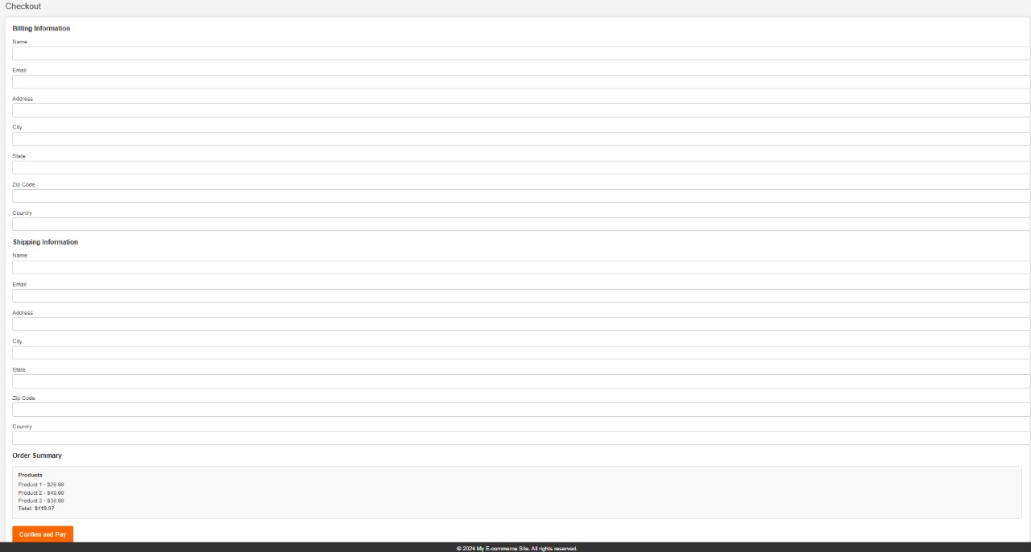

**REFERENCES:**

Website:

1. <https://www.geeksforgeeks.org/e-commerce/>
2. <https://www.blackbox.ai/>
3. <https://openai.com/index/chatgpt/>

Vidoes:

1. <https://www.youtube.com/results?search_query=html+css+project+e+commerce>+
2. <https://www.youtube.com/watch?v=zZ6vybT1HQs>
3. <https://www.youtube.com/results?search_query=dbms+project+on+e+commerce>+

Books:

1. **"SQL in 10 Minutes, Sams Teach Yourself"** by Ben Forta
2. **"PHP: A Beginner's Guide"** by Vikram Vaswani

**Conclusion**

In conclusion, the development of a robust e-commerce platform requires the seamless integration of multiple technologies, combining frontend design, backend functionality, and efficient database management. The frontend of the platform is designed using **HTML** and **CSS**, providing well-structured and visually appealing web pages for product listings, shopping carts, and the checkout process. These pages are optimized to deliver a smooth, intuitive user experience, ensuring customers can easily navigate through the product catalog, add items to their cart, and complete purchases without any friction

On the backend, **PHP** is used to manage the dynamic aspects of the platform. The backend PHP code is responsible for handling complex tasks such as interacting with the database, managing user sessions, and processing orders. By leveraging PHP's server-side capabilities, the platform ensures secure user authentication, smooth session management, and efficient data retrieval for product details, inventory status, and customer orders.

To effectively manage the data that powers the platform, a well-structured **relational database** is employed, with the **Entity-Relationship (ER) diagram** helping to visualize and organize the relationships between key data entities, such as customers, products, orders, and inventory. This diagram ensures that the data flow is logical and efficient, minimizing redundancy and supporting the scalability of the platform as it grows. By maintaining clear relationships between these entities, the system can handle large volumes of transactions and customer interactions without compromising performance or data integrity.

The integration of these components—frontend, backend, and database—results in a comprehensive e-commerce solution that not only meets the functional requirements of an online shopping platform but also offers a seamless, engaging experience for users. By combining modern web development techniques with strong backend architecture and a well-designed database structure, we have created a platform that is both user-friendly and scalable, simplifying the online shopping experience for customers while ensuring efficient management and operations for administrators. This e-commerce platform ultimately enhances user engagement, drives sales, and positions the business for growth in a competitive online marketplace.